Stats Video Lecture – Bayesian Inferences

Wee 2, Lecture 7

Source: 1 six sided Die, 1 12 sided Die, guess which hand is holding which dice. We will know each time a die is rolled if it rolled something greater than or equal to 4.

P(>=4 | 6sides) = ½, P(>=4 | 12 sides) = 3/4

Probability Tree after 1 roll:

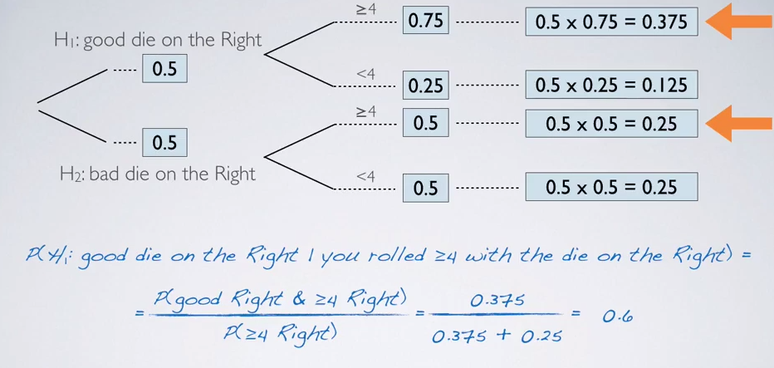

1. Posterior Probability
   1. Defined as P(Hypothesis|data observed)
   2. it tells us the probability of a hypothesis we site forth, given data we just collected
   3. Depends on both prior probability and observed data.
   4. Different than the **pValue which is P(data|hypothesis)**
2. Bayesian Interferences
   1. claims are evaluated iteratively as we collect more data
   2. we repeat the P-tree with the next roll, updating our prior with a proterior probability